AIT 642 / COSC 603

Software Testing and Maintenance

Spring 2016

**Project #1 – Reengineering Legacy Systems**

**Task 3 – Using Eclipse and Git / GitHub Desktop for Configuration Management.**

I completed the Git course at codeacademy which was interesting but long.

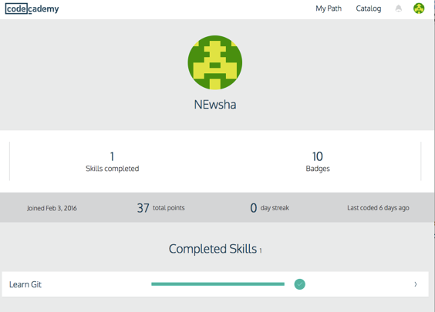

I also complete the tutorial of GitHub Desktop but couldn’t really use it. I did most of my experiment committing/pushing/pulling etc using eclipse and then checking the result on GitHub website. The idea of GitHub is great and exciting. However, it was confusing and I still need to explore/experiment more to get comfortable working with it.